Nonjabulo Mathenjwa

ST10077892

INSY6112

EXAM

17 June 2025

Question 1

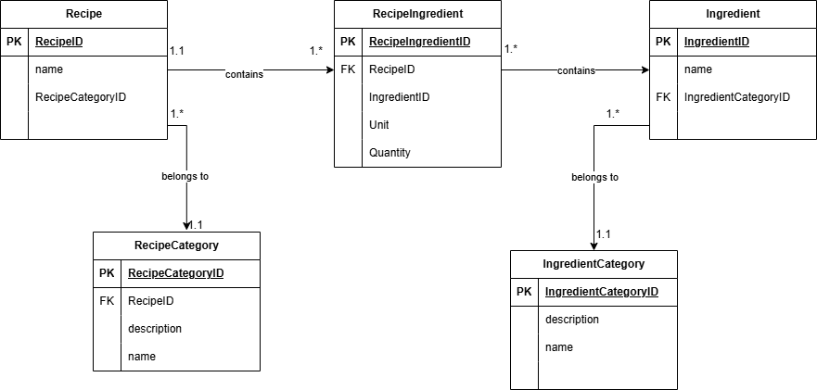

Question 2

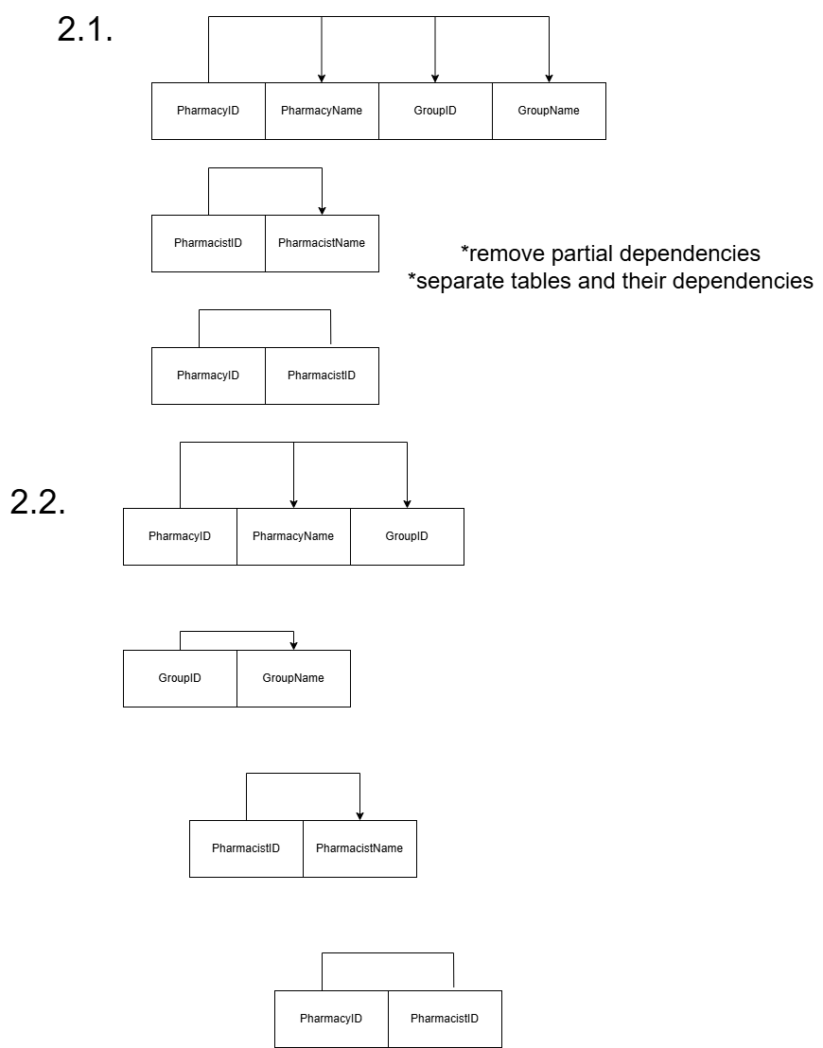

Question 4

